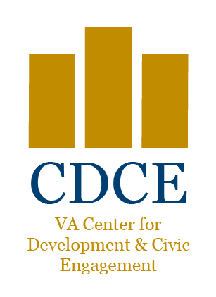
VOLUNTEER AND COMMUNITY RELATIONS (00CO-VCRS)
DETROIT VA HEALTHCARE SYSTEM
4646 JOHN R
DETROIT, MICHIGAN 48201

SUPPLY NEEDS
UBER OR LYFT GIFT CARDS DEODORANT
SLIPPER SOCKS WITH NON-SLIP SOLES LIQUID SOAP
WHEELCHAIR GLOVES READING EYE GLASSES
WHITE SOCKS (NO ELASTIC) NAIL CLIPPERS
HAIR BRUSHES EMORY BOARDS
LARGE COMBS (NO RAT-TAIL COMBS) TOOTHPASTE & TOOTHBRUSHES
SHAVING CREAM & RAZORS FINGER & TOE NAIL CLIPPERS
(NEW) BRIEFS/T-SHIRTS/BOXERS (NEW) HATS and GLOVES
SHAVING MIRRORS STAMPS (MAIL VETERAN LETTERS)
SHAMPOO MOUTHWASH, NON-ALCOHOLIC
HAND & BODY LOTION (NEW) SHOES (MEN – sized 9-13, WOMEN – sized 6-9)

**PLEASE NOTE: trial/travel sizes only for all shampoos, lotions, soaps etc. Thank you**
ITEMS WE CANNOT ACCEPT

BAR SOAP (INFECTION CONTROL) CASSETTE TAPES AND VCR TAPES
USED PLAYING CARDS HOME BAKED GOODS
ARTIFICIAL LIMBS, CRUTCHES, WALKERS NATIONAL GEOGRAPHIC MAGAZINES
MEDICAL EQUIPMENT HAIR PICKS (METAL)
MATCHES GLASS CONTAINERS
CIGARS OR CIGARETTES PENS/PENCILS
BOOKS USED CLOTHING
NOTEPADS/NOTEBOOKS ALCOHOLIC BEVERAGES
RECREATION ITEMS
TABLE GAMES (MONOPOLY, CHECKERS, SCRABBLE, CHESS, ETC.),
CDs/ DVDS/VIDEO GAMES
RUG KITS AND CRAFT SUPPLIES; i.e., NEEDLES, YARN, THREAD, ART BRUSHES, BEADS, ETC.
PAINT BY NUMBER KITS CROSSWORD PUZZLE BOOKS
WORD SEARCH BOOKS MODEL KITS (CARS, SHIPS, ETC.)
(NEW) PLAYING CARDS
HONOR KIT ITEMS:
Voluntary Service provides each new inpatient with an Honor Kit. Below are travel-size suggestions to include in these kits. These bags may include a thank you from your group.
DEODORANT (NON-AEROSOL) | TOOTHPASTE | LOTION (2ea)
SHAMPOO (2ea)  CONDITIONER (2ea)  COMB | TOOTHBRUSH  DENTAL FLOSS  PUZZLE BOOK
KNITTED/HAND CRAFTED ITEMS:

* Patterns are available for these items if interested.
- FEEDING BIBS (18 X 36)
- TRACHEOTOMY BIBS
- LAP ROBES (48 X 48)
- AFGHANS (40 X 60)
- WHEELCHAIR BAGS

SNACKS

These snacks are provided to patients who are undergoing testing that requires fasting, or for those who may be food insecure.
- INDIVIUALLY WRAPPED SNACKS:
    - CRACKERS
    - CHIPS
    - COOKIES
    - PROTEIN BARS
    - GRANOLA BARS
    - TRAIL MIX
- JUICES (10oz AND SMALLER)

Please visit us on line at www.detroit.va.gov/giving
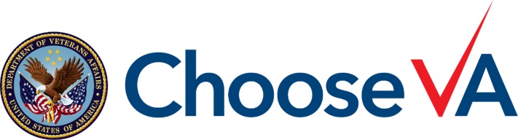

FOR MORE INFORMATION TO DONATE OR TO VOLIUNTEER PLEASE CONTACT US AT
(313) 576-3332
vhadetvavs@va.gov
THANK YOU FOR HELPING AMERICA’S HEROES!
